**SoftUni OOP Game Contest**

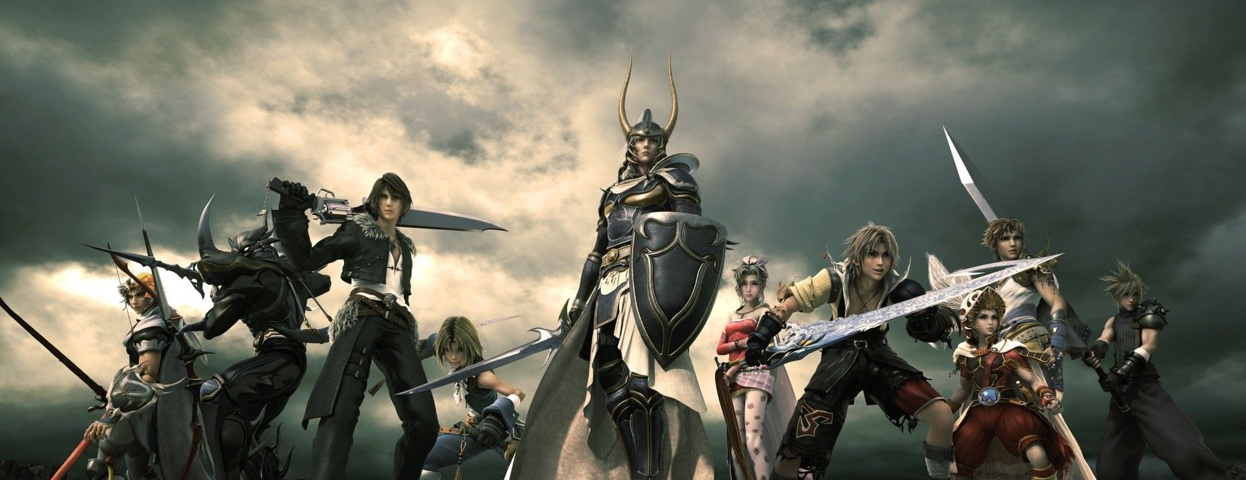

SoftUni is organizing a contest for the best **role playing game** from the OOP teamwork projects. The winnig teams will receive a **grand prize**!  
The game shoud be:

* + Properly structured and follow all good OOP practices
  + Awesome
  + ...Very Awesome

|  |  |  |
| --- | --- | --- |
| **Team** | **Game** | **Points** |
| - | - | - |
| - | - | - |
| - | - | - |

The top 3 teams will receive a **Spectacular** prize:

**A handshake from Nakov**